E-METER DATA

As a biographical note I spent nearly 10 years in the Sea Org from 1972 - 1982. I repaired E-meters on board the Apollo and at the FLB. I trained as an auditor up to Cl V at the FLB and have since audited many thousand hours at NOTs level on self and others.
The Mk V E-Meter as originally used in the CofS suffers from several major faults. The major trouble is that it is insufficiently sensitive to pick up reads on OT level 5 and above. At the higher levels one is often dealing with small reads sometimes through a fast moving needle.
The CofS attempted to produce a better meter in the Mk VI. While the quality of some parts was improved the essential circuit was very similar to the Mk V. The major change was in the meter movement. My own tests indicate that the Mk VI is actually less sensitive than the Mk V. The Mark VII is a much improved product that uses a superior quality of movement and picks up many more reads. Unfortunately the CofS appears to have an arbitrary in the design spec. The Mk VII movement, in common with earlier models does not come to rest after a read for several seconds. It actually swings 8-10 times before settling. This uncontrolled movement can obscure and confuse reads. I have recently had a meter movement produced that does not swing about after a read. An increased torque in the coil produces a faster needle response to changes in the pc. Using a device that I built a pc can be connected to 2 meters simultaneously. Comparisons using it show reads on the improved design not present on any CofS meter.
I have written up data on the E-Meter with full circuitry and specification: E-Meter Circuit
Ralph Hilton

The E-Meter Circuit
The following is a detailing of the complete circuit for an E-Meter. This is placed in the public domain for use without restriction.
A somewhat simpler circuit could be designed for experimentation but this one contains all I have found necessary for an effective meter to use through all the upper levels.
I generally use disposable batteries. With low current op-amps such as the MC33174 the total power consumption of the circuit is under a milliamp.
To maintain calibration the circuit should be powered through a 5 volt regulator. A low power type should be chosen. These standardy come as 3 terminal devices. One terminal goes to a common ground, one to the battery +ve and the other is the regulated output. A 100uF capacitor should be connected across teh 5 volt supply for stabilization.
The meter uses a quad op-amp. The MC33174 works well. If it is not available then others such as a TL074 should be fine but the power consumption is higher.
I shall detail the circuit in parts and explain each. Firstly the circuit requires a bias voltage. One of the op amps is used to provide this:
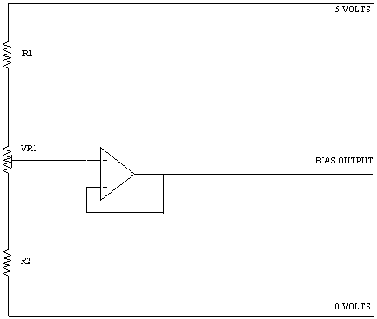
R1 100K, R2 47K, VR1 100K preset
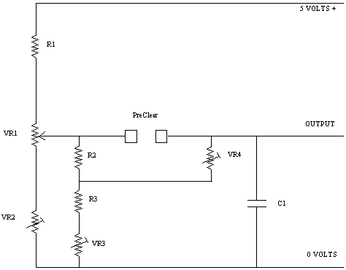
This is main bridge circuit.
R1 10k, R2 22k, R3 5.6k
VR1 is the TA pot and should be a good quality wirewound 20k
VR2 50k preset for adjusting TA 3.0
VR3 10k preset for adjusting TA 6.5
VR4 10k preset for adjusting TA 2.0
C1 is .001uF for removing R.F.
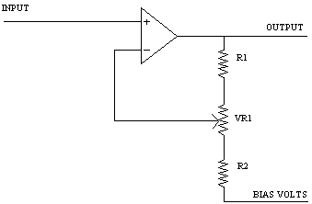
The output goes to this next stage which is the main amplifier controlled by the sensitivity pot:
VR1 is a good quality 20k wirewound pot. R1,R2 = 1.5K

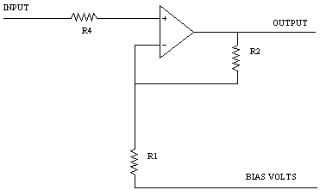
This section gives additional gain so that the sensitivity pot range is spread more evenly. R1,R4 = 22k. R2 = 100k

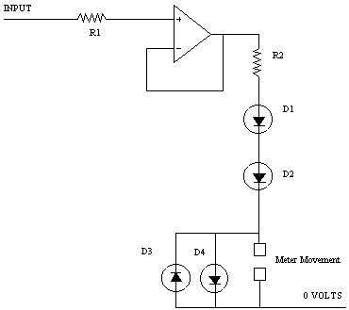
Finally an output buffer is used to prevent any back e.m.f. from the meter movement causing unwanted changes in the negative feedback path.
R1 22k, R2 1k .
The diodes are standard silicon signal diodes.
The meter movement is a high quality 100 microamp F.S.D. taut band movement. It needs to have a fast response with the needle coming to rest as quickly as possible. The CofS use a movement which is underdamped and takes 3 seconds to come to rest. This makes the meter difficult to read and has no advantages that I have seen.
The circuit is calibrated in several stages:
1. Adjust the bias voltage so that with the needle on "set" adjusting the sensitivity does not appreciably move the needle.
2. Adjust the TA6.5 preset so that the needle comes to set with no resistance across the PC connections.
3. For calibrating TA2 and TA3 resistors of 5K and 12.5K are required. The presets need to be adjusted so that TA2 and TA3 are both positioned correctly. TA6.5 may then need to readjusted. The 3 presets are interdependant so it will probably be necessary to readjust them in sequence several times.

